Type of Manuscript: Original Research Article
Title (the first letter of all notional words should be capitalized)
For Special Issue Submission: This manuscript is submitted to Special Issue Title and/or invited by Guest Editor’s Name.
For Regular Submission: This manuscript is a regular submission.

Abstract
The abstract should be up to 500 words and structured to contain the following headings: Background/Objectives, Methods, Results, and Conclusions. Background/Objectives: Place the question addressed in a broad context and highlight the purpose of the study; Methods: Describe briefly the main methods or treatments applied. Include any relevant preregistration numbers and species and strains of any animals if used; Results: Summarize the article’s main findings; Conclusions: Indicate the main conclusions or interpretations. The abstract should be an objective representation of the article: it must not contain results that are not presented and substantiated in the main text and should not exaggerate the main conclusions. It should not contain any non-standard abbreviations, acknowledgments of support, references, or footnotes.
Keywords: Keyword 1, Keyword 2, Keyword 3, Keyword 4, Keyword 5, Keyword 6

1. Introduction
Standard English is desirable throughout the text. Abbreviations should be spelled out when first used. Integers below ten should also be spelled out (“six” instead of “6” for example). If non-English words are used, such as de facto, please italicize them. Authors are encouraged to have their manuscripts proofread and English edited by native speakers before submission.
Do not use footnotes in every section of the manuscript. Avoid using sub-sections in the first section, commonly known as the Introduction or Background.
Define abbreviations and acronyms upon their first appearance, separately, in the Abstract, Main Text, Table legends, and Figure captions and legends.
In-text citations listed in the References section at the end of the submission should be numbered consecutively in superscript. For example: Multidisciplinary research spans many disciplines ¹. This result was later contradicted by McClusky and McCarthy ^{2,3}. This effect has been widely studied ^{4–6}. This hypothesis is supported by many schools of thought ^{3, 7–9}.

2. Materials and Methods

2.1 Materials
State all the materials used in the study, and include the manufacturer’s name, city, and country of origin.

2.2 Method 1
Describe the method clearly and concisely.

2.3 Method 2
Describe the method clearly and concisely.
Use Arabic numerals in parentheses, e.g., (1), (2), (3), (4), to list equations and formulae. Please define all the variates in the equations and cite the equations in the manuscript.
e.g., E=mc² (1)

2.3.1 Description A
AiN allows up to 3 levels of headings.

2.3.2 Description B
Avoid introducing further sub-sections after the level 3 (e.g., 2.3.2.1. Sub-description).

2.4 Statistical analysis
Include at least one paragraph describing the statistical tests and software used for data analysis.

3. Results

3.1 Result A
Describe the result clearly and concisely. All Figures and Tables presented in the paper must be cited in the text in chronological order. The resolution of Figures should be high, to guarantee all the details and words are properly presented. Please pay special attention to the font, font size, line space, etc. in Figures and Tables. All the abbreviations special marks, and special layout (font colors, background colors, highlights, italic words, bold words, etc.) should be defined. Please note that the Table cannot be an image or screenshot and prepare it in plain text or use the Microsoft Word Table functions.
For instance, Figure 1 shows xxxxxx, and Table 1 presents xxxxxx. xxxxxx can be found in Figure 2/Table 2. Meanwhile, the Figures and Tables should appear after the paragraph of their first citations.

Figure 1. Give the title of Figure 1 and the figure caption should be beneath the image.
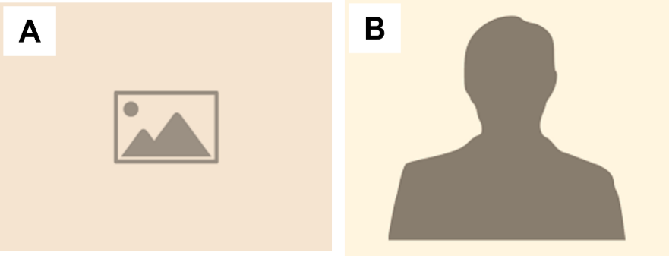
Figure 2. Title of Figure 2. (A) Give a proper title to every subfigure. (B) Give a proper title to every subfigure.
Table 1. The table caption should be placed on top of the table.
Parameters | Temperature
 | xx°C | xx°C | xx°C
Parameter A | xx | xx ^{b} | xx
Parameter B | xx ª | xx | xx
Add a legend below the table. Define all abbreviations used in the table in alphabetical order and define the symbols used. ª P <0.05, ^{b} P <0.01.
Table 2. The table caption should be placed on top of the table.
Parameters | Light Intensity
 | Low | Moderate | High
Parameter A | xx | xx ^{b} | xx
Parameter B | xx ª | xx | xx
Add a legend below the table. Define all abbreviations used in the table in alphabetical order and define the symbols used. ª P <0.05, ^{b} P <0.01.
Materials that have been published previously should be accompanied by written permission from the copyright holder, such as author(s) and publisher. The statement of written permission should be written in the copyright holder’s preferred style.
Personal communications and unpublished works can only be used in the manuscript and are not to be placed in the References section. These should be made identifiable by stating the authors, year of personal communications or unpublished works, and the words “personal communication” or “unpublished” in parenthesis, e.g., (Smith J, 2000, unpublished).

3.2 Result B
Describe the result clearly and concisely. All Figures and Tables presented in the paper must be cited in the text in chronological order; for instance, Figure 3 (A) shows xxxxxx, while Figure 3(B) shows xxxxxx, and Table 3 presents xxxxxx.

3.3 Result C

3.3.1 Description A
AiN allows up to 3 levels of headings.

3.3.2 Description B
Avoid introducing further sub-sections after the level 3 (e.g., 2.3.2.1 Sub-description).

4. Discussion
Discussion can be presented alone, independent of the Results section. Alternatively, Discussion can also be merged with Results as “3. Results and Discussion”, and sub-sections can be used for better presentation too.
In-text citations that will be listed in the References section at the end of the submission should be numbered consecutively in superscript. All references must be cited in numerical order (consecutive positive sequence).

5. Conclusion
Conclusion should present the most important findings and conclusions in this section. A summary of the manuscript, results, findings, limitations, etc. can be discussed.

References
AiN adopts a slightly modified version of the Vancouver style for reference. When there are more than four authors, shorten the list to the first three authors and add “et al.” Journal titles should be abbreviated according to the PubMed standard. Here are examples of how references should be formatted:
- Journal Article:
1. Abate, M., Salini, V., Rimondi, E., et al. Post-traumatic myositis ossificans: sonographic findings. J Clin Ultrasound. 2011;39(3):135–140. doi: 10.1002/jcu.20792.
- Book:
2. Cardenosa, G. Breast Imaging Companion, 3rd edition. Lippincott Williams & Wilkins: Philadelphia, USA, 2007. pp. 24–29.
- Chapter in a Book:
3. Galloway, A.C., Colvin, S.B., Grossi, E.A., et al. Acquired heart disease. In Principles of Surgery, 6th ed.; Schwartz, S.I., Shires, G.T., Spencer, F.C., eds. McGraw-Hill: New York, USA, 1994. pp. 845–899.
- Conference Proceedings:
4. Author 1, A.B.; Author 2, C.D.; Author 3, E.F. Title of Presentation. In Title of the Collected Work (if available), Proceedings of the Name of the Conference, Location of Conference, Country, Date of Conference; Editor 1, Editor 2, Eds. (if available); Publisher: City, Country, Year (if available); Abstract Number (optional), Pagination (optional).
- Unpublished materials intended for publication:
5. Author 1, A.B.; Author 2, C. Title of Unpublished Work (optional). Correspondence Affiliation, City, State, Country. year, status (manuscript in preparation; to be submitted).
6. Author 1, A.B.; Author 2, C. Title of Unpublished Work. Abbreviated Journal Name year, phrase indicating stage of publication (submitted; accepted; in press).
- Unpublished materials not intended for publication:
7. Author 1, A.B. (Affiliation, City, State, Country); Author 2, C. (Affiliation, City, State, Country). Phase describing the material, year. (phase: Personal communication; Private communication; Unpublished work; etc.)
- Thesis:
8. Author 1, A.B. Title of Thesis. Level of Thesis, Degree-Granting University, Location of University, Date of Completion.
- Websites:
9. Title of Site. Available online: URL (accessed on Day Month Year).
Unlike published works, websites may change over time or disappear, so we encourage you to create an archive of the cited website using a service such as WebCite. Archived websites should be cited using the link provided as follows:
10. Title of Site. URL (archived on Day Month Year).

